**Girls wear**

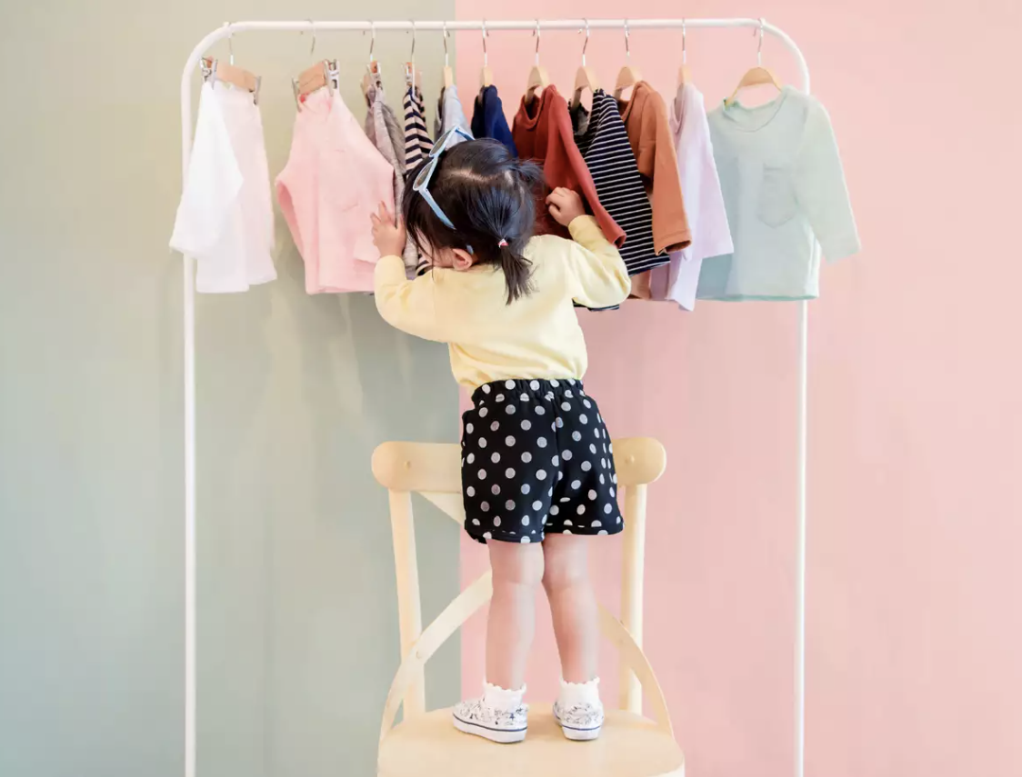

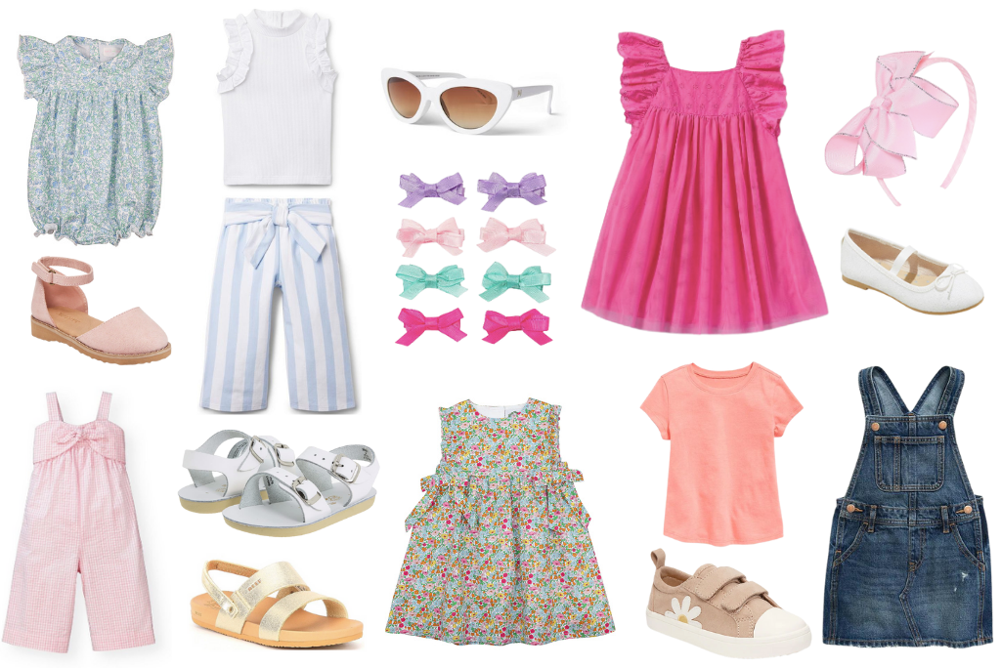

Attractive clothes for your princess

We're a clothing brand that is committed to making the highest quality garments, using beautiful fabrics, colorful, in a comfortable & fun design. We love life and know that our clothes should make your girl feel good too.

Boys wear

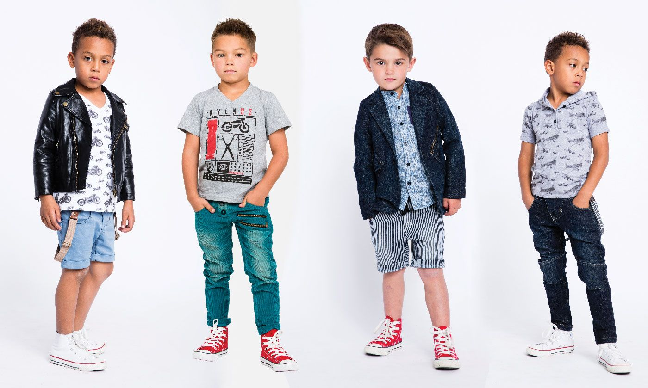

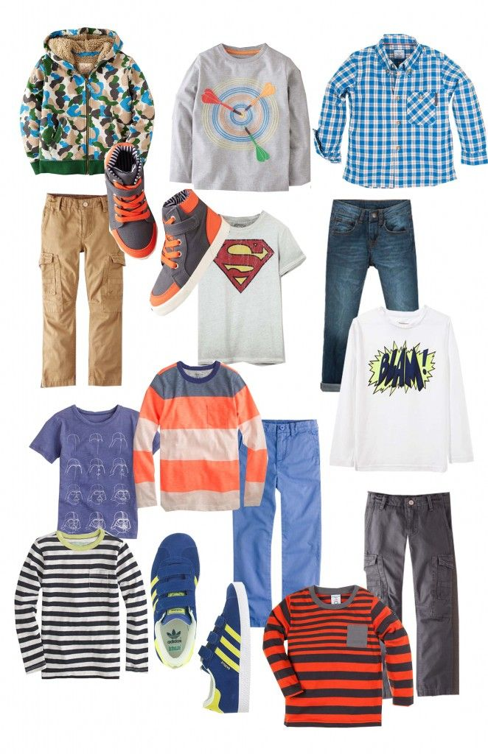

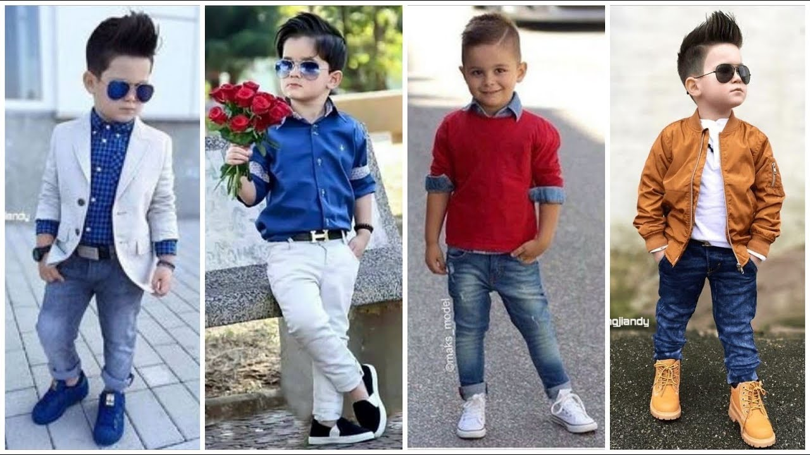

Give your baby a stylish look

Browse our beautiful range of kids clothing for everything you need to update your little one's wardrobe to keep them looking stylish. Choose from plenty of gorgeous styles for baby boys.

Footwear

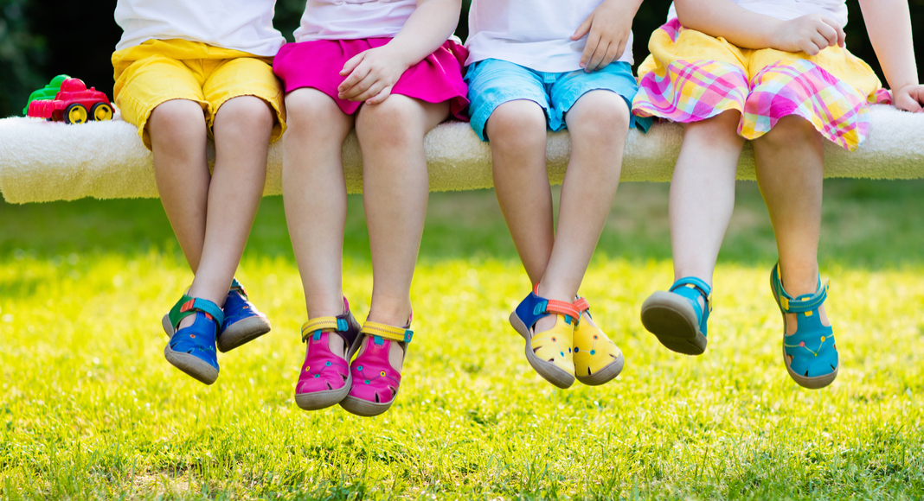

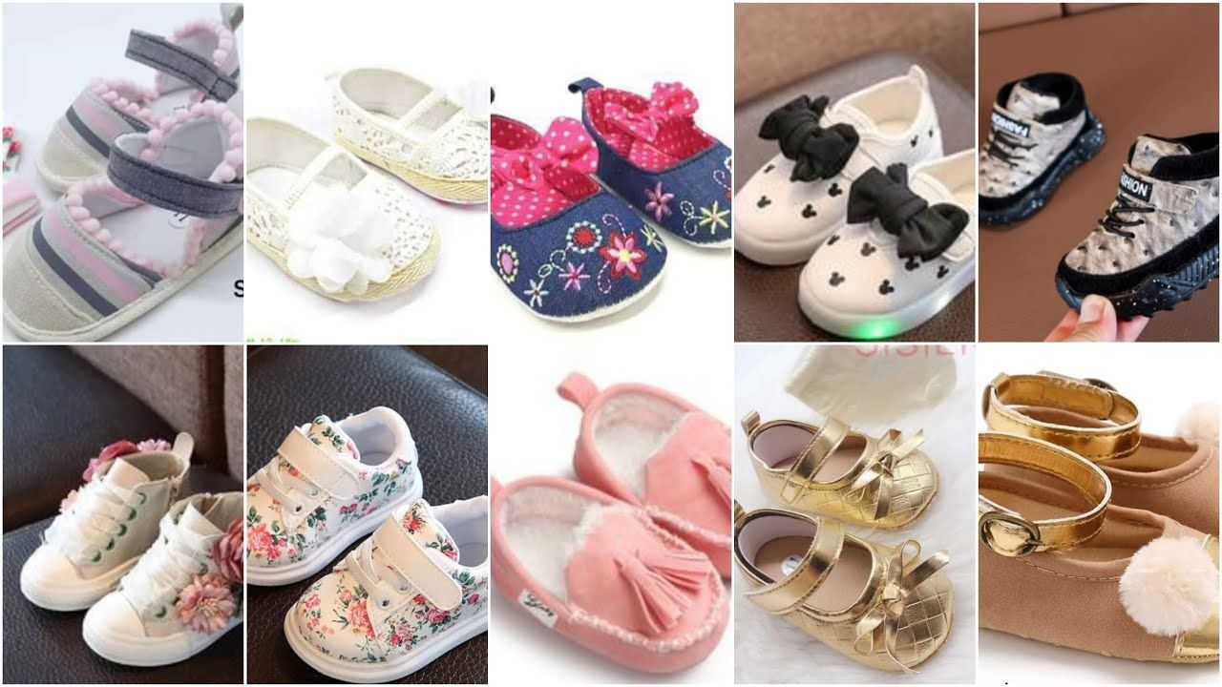

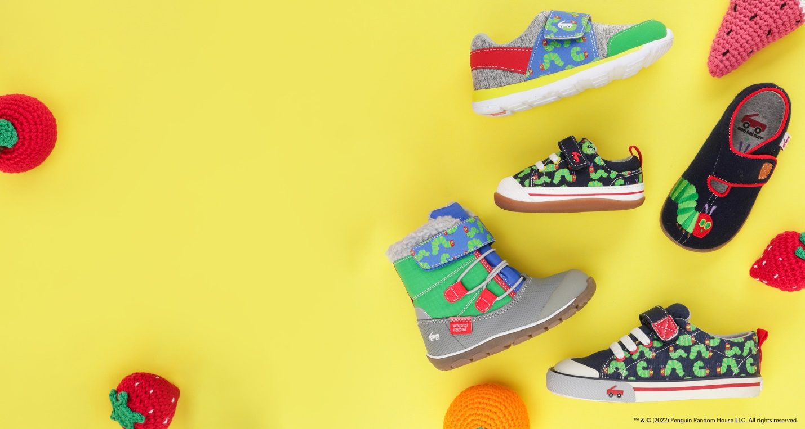

Give your kids a taste of elegance.

just the thing to make sure your little one looks seriously stylish. Of course, no look is complete without some kids’ shoes. Check out our range to find everything from booties to classic moccasins.

Toys

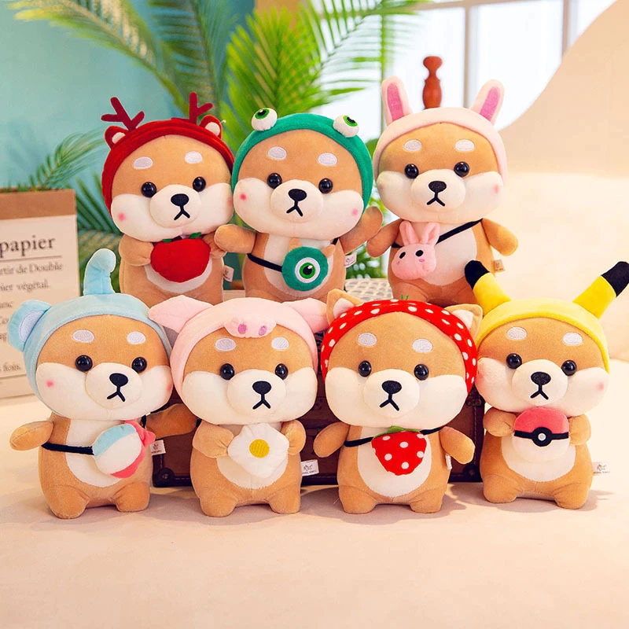

Toy- The love you give to your child

There’s also a great selection of kids’ toys, helping your baby to have fun splashing around.